Setting up IntelliJ for VASL Development

Use this document to get up and running with VASL development in IDEA IntelliJ. Note that this document will cover all steps necessary to do VASL development. If you are working on the module and/or boards there are a number of steps you can skip. I’ve noted these where appropriate.

Install IDEA IntelliJ Community edition

You can find IntelliJ here: http://www.jetbrains.com/idea/download/ If the link is stale Google is your friend.

Make a note of where you set your workspace – this is where your VASL project files will live.

Create the VASL project

Start IntelliJ. You should see an introduction screen with the option to create a new project. Select that option.
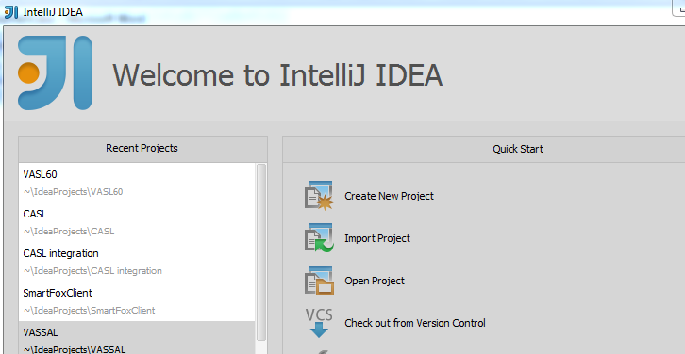

You will see the following screen:
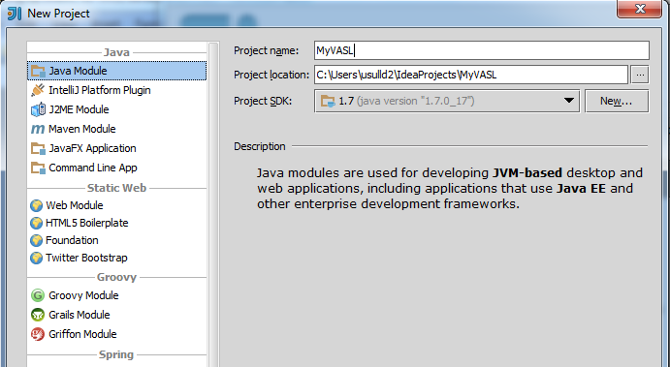

Select “Java Module” for the project type and give your project a cool name (MyVASL in this case). Note the project location – you can change it if you like, otherwise it will use your default workspace. Click “Next.” You may get a screen to “add technologies” to your project. You can ignore this and click “Finish.”

You should have an empty project at this point:
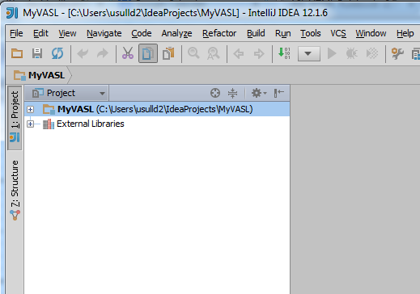

Finding the VASL code

The VASL code is located on SourceForge: http://sourceforge.net/projects/vassalengine/

On the main page, about a third of the way down, you’ll see a set of tabs starting with “Summary|Files|etc.” The right-most tab is “SVN.” Click that and you will see all of the VAS(SA)L code:
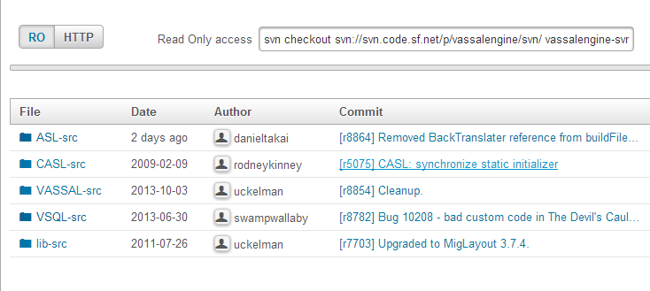

Note the URL for read only access (RO) looks something like:

svn checkout svn://svn.code.sf.net/p/vassalengine/svn/ vassalengine-svn

This is used with the Subversion command line client. The interesting bit needed for IntelliJ is the repository URL:

svn://svn.code.sf.net/p/vassalengine/svn/

We’ll use this URL in IntelliJ to check out the source code. If you have write access to the VASSAL project on SourceForge you will have a read/write (RW) option:

svn checkout --username=davidsullivan1 svn+ssh://davidsullivan1@svn.code.sf.net/p/vassalengine/svn/ vassalengine-svn

The read/write URL is this part (where davidsullivan1 is your SourceForge user name).

svn+ssh://davidsullivan1@svn.code.sf.net/p/vassalengine/svn/

I’ll assume you have read/write access for the remainder of this document.

A quick note on the code. VASL is collocated with the VASSAL source code, so there are a number of directories here you do not need. Here’s a rundown on the folders:

ASL-src | The VASL code
CASL-src | The VASL LOS code
VASSAL-src | The VASSAL source code.
VSQL-src | The VSQL (Squad Lead) source. It also contains code for a couple of other games
lib-src | Source code for some of the libraries used by VASSAL

The only folder needed for VASL is ASL-src; the rest can be ignored.

Checking out the VASL code
In IntelliJ select the “Browse Subversion Repository” menu option:
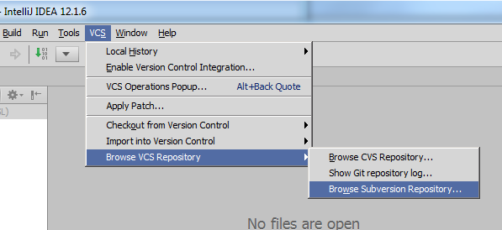

Click the green “+” button to add a new repository and enter the appropriate URL:
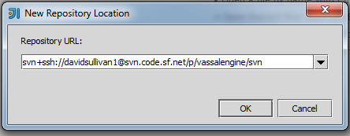

Once set, expand the repository and then expand the “ASL-src” folder. Right-click on the “trunk” folder and select “Checkout…”
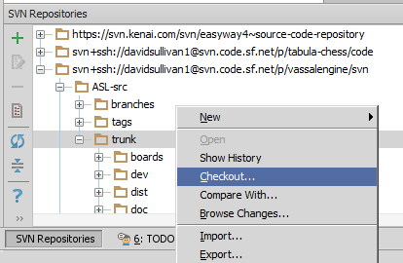

Select your project directory in the next dialog:
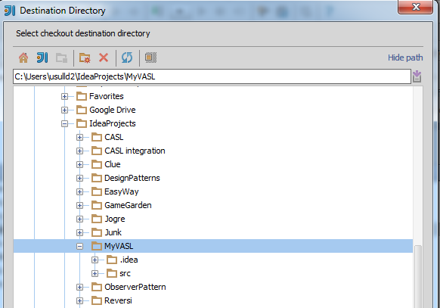

On the check-out options make sure your project directory is selected. Otherwise, don’t change anything.
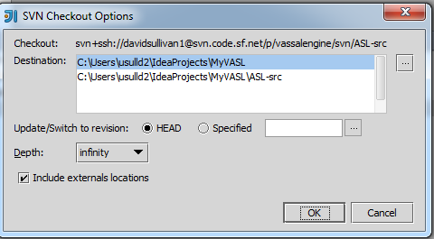

You’ll get a dialog to select the Subversion “working copy format” – leave it as 1.7 and click “OK.” IntelliJ will spin for awhile as the files are copied to your project directory.
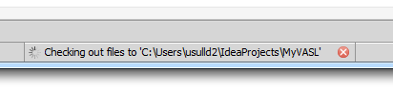

When the checkout is complete you’ll get a dialog asking if you want to create a new project. Click “No.” You should now see the following structure in your project:

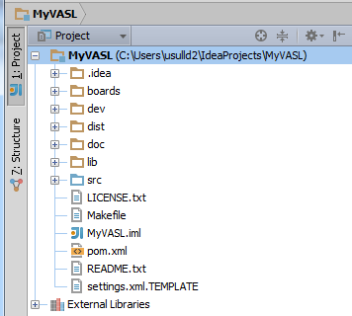

IMPORTANT! – If you are going to be making code changes of any significance you should create a branch, work in that branch and then merge your changes into the trunk. If you are working on the boards or module you should be OK working directly in the trunk.

Adding library dependencies (Developers only)

All of the jars in the library folder need to be added to your project’s class path. IMPORTANT – the VASSAL jar must come first in the class path. Use File -> Project Structure… to do this.
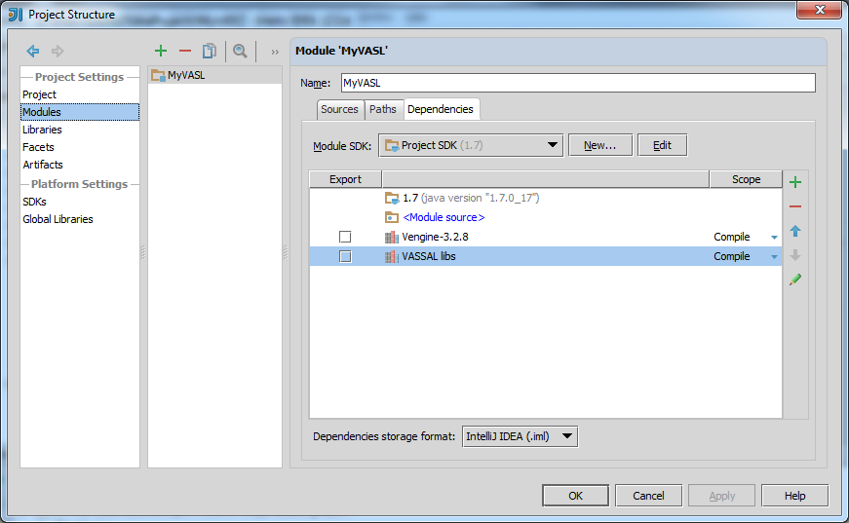

Use the green “+” to the right to add the libraries. The second line contains all jars except the VASSAL jar. Note that the VASSAL jar is the top line, which is correct.

Now make your project. Go to the “Build -> Make project” menu (Ctrl+F9) and VASL should build. There will be a few warnings, which can be ignored.

To run VASL from IntelliJ use the following run configuration (“Run->Edit configurations” menu):
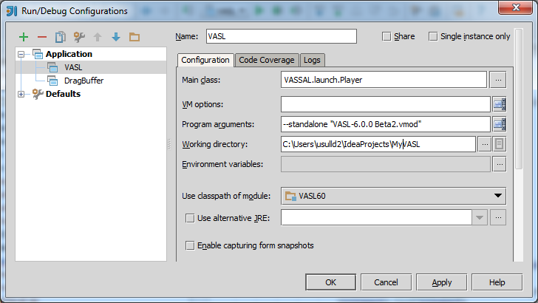

Create a new Java application. Note the program arguments – in this case we assume the VASL module (6.0.0 beta 2) is in the IntelliJ project directory (recommended). You must use quotes around the module name.

Also, the VASL module includes the compiled VASL classes, which acts like a jar file. IntelliJ will put your local changes ahead of the classes in the module so the module code will never be used.

Click “OK” and then make sure VASL runs. You’ll have to set your VASL preferences, etc. the first time you run.

Checking in changes
You must first enable integration of Subversion in IntelliJ before you can check in changes. Once enabled IntelliJ, via Subversion, will track all changes in your project directory and make them available to check in.

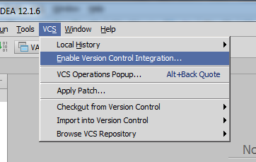

In the dialog select Subversion:

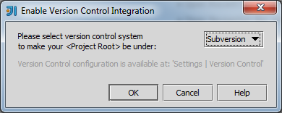

To add files to the repository, right-click on the file in the project browser and used the “Add” menu option:

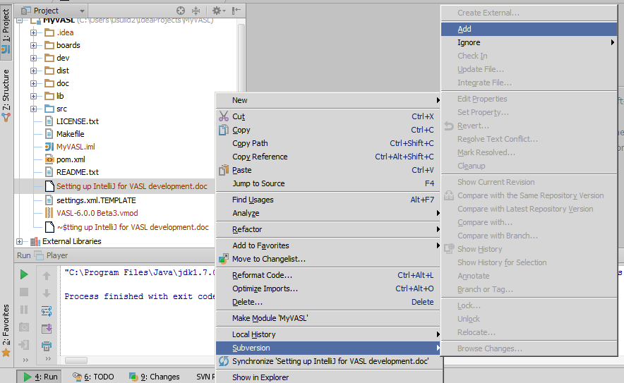

In this case I’ve adding this document, which is in the project root folder.

Use the “Commit changes…” menu to see what changes you have locally and commit them to SourceForge.

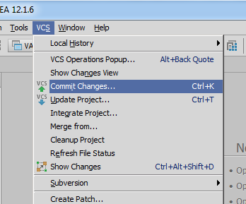

You can see the document I’ve added shows up in my list of changes.
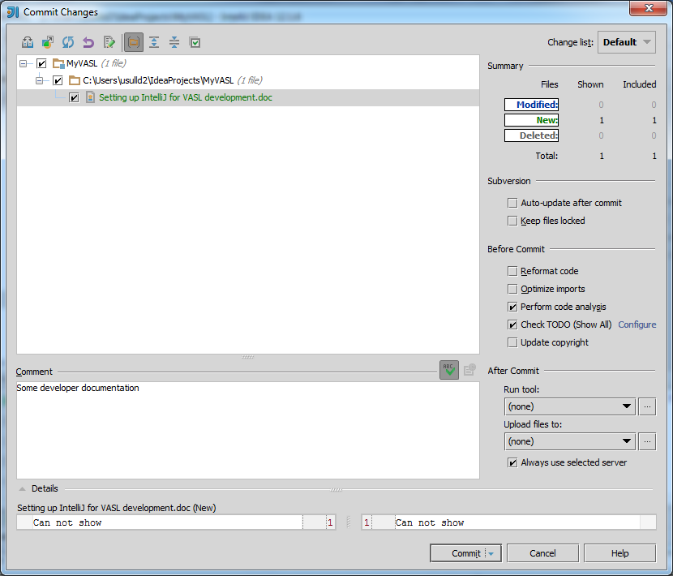

Changing a file that’s already in the repository is similar, except that for text files you can inspect the specific lines that are being changed before checking in the changes.

